
Store Hours
Mon to Sat.
10 AM to 10 PM
Sunday
10 AM to 8 PM

308 Wootton Street
Boonton, NJ 07005
PH: 973-331-5125 FX: 973-331-5127
www.buyritediscountliquors.com
COUPON
10% OFF
12 OR More Bottles of 750 ML
Wine, Port, sherry
Exclude sale items
Beers
Over 600 Beer to choose from
Try our wall of singles
Make your own 6 Pack
SPIRIT
Absolut vodka (reg.) 1.75L ----------------------------$29.09
Tito Vodka 1.75L----------------------------------------$29.09
Belvedere Vodka1.75L----------------------------------$49.99
Seagram 7 1.75L ----------------------------------------$18.99
Seagram VO 1.75L -------------------------------------$19.99
Grey Goose Vodka1.75L-------------------------------$49.09
Ketal One Vodka 1.75L---------------------------------$39.09
Skyy Vodka 1.75L----------------------------------------$21.09
Smirnoff Vodka 1.75L ----------------------------------$20.99
Sobieski Vodka 1.75L-----------------------------------$19.99
Svedka Vodka 1.75L -----------------------------------$19.29
Three Olives Vodka1.75L------------------------------$24.99
Fire Ball 1.75 ---------------------------------------------$27.99
Chivas Regal 1.75L -------------------------------------$58.99
Bulleit Bourbon 750 -------------------------------------$28.09
Bulleit Bourbon 95 RYE750 -------------------------- $28.09
Balvenie 12 yr Doublewood 750 ---------------------$51.99
Bailey Irish Crème 1.75 --------------------------------$39.99
Laphroaig single malt 10 year 750-------------------$48.99
Jack Daniels 1.75 Ml -----------------------------------$44.99
Luksusowa Potato 1.75 --------------------------------$23.99
Jameson 1.75ML ----------------------------------------$51.99
Perrior J Brut 750 ----------------------------------------39.99
Johannie walker Blue 750ML ----------------------- 179.09
Johannie walker Black 1.75L--------------------------$59.09
Johannie Walker Red 1.75L --------------------------$32.99
Patron Silver 750 ---------------------------------------$39.99

WINES
Barefoot All types 1.5L ---------------------------------$10.99
Beringer (Classic) All type 1.5L -------------------------$9.99
Black Box All types 3L ---------------------------------$21.99
C K Mondavi All types 1.5L-------------------------$10.99
Cavit All types 1.5L ------------------------------------$13.99
Clos Du Bois All types 750ML ------------------------$9.99
Kendall Jackson Chardonnay 750 ML-----------$12.99
Liberty Creek All types 1.75 --------------------------$7.99
Mark West Pinot Noir 750 ML------------------------$9.99
Mark west Pinot Noir 1.5LML ----------------------$17.99
Mezzacorona Pinot Grigio 1.5L -------------------$12.99
Menage A Trois Red 750 ML -----------------------$9.99
Apothic red 750 ML------------------------------------$9.99
Santa Margrita Pinot Grigio 750 ml---------------$20.99
Kim Crawford Sauv BL 750-------------------------$13.99
Woodbridge All types 1.5L -------------------------$11.99

May Special 2018
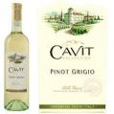
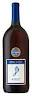
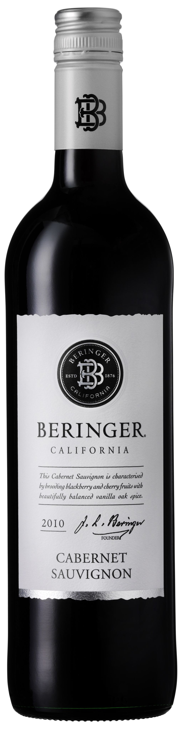
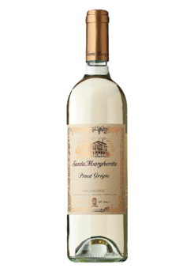
ABC Prices Prevail other prices, limited to store inventory. Not responsible for typographical errors. Prices valid till May, 2018
We Specialize in hard to find items and custom order, just ASK!

